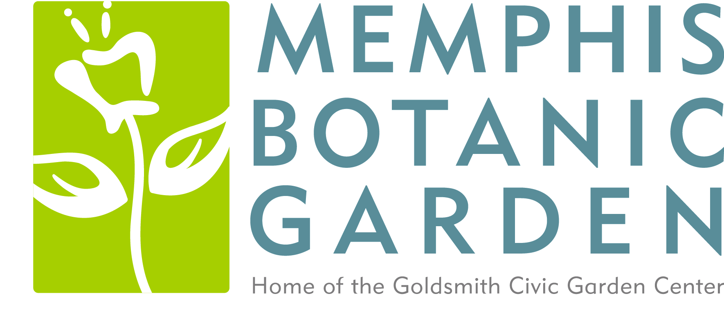

MEMPHIS BOTANIC GARDEN FOUNDATION
VOLUNTEER PARTICIPATION FORM

Hold Harmless:
I, __________________________________ (print full name) agree to release, discharge, indemnify, and hold harmless in perpetuity the Memphis Botanic Garden Foundation, its officers, directors, agents, assignees, and successors, and the City of Memphis from and against any and all actions, claims, suits, demands, damages, losses, and expenses which may accrue as a result of volunteering for any activity on behalf of the Memphis Botanic Garden.
Photo Release:
In consideration of my participation in the activities described above, I agree to this Photo Release Form. I grant Memphis Botanic Garden and its volunteers, employees, agents, representatives, and licensees permission to copy, edit, publish and otherwise use my name, image and likeness, with or without my name, including for marketing purposes or for any other lawful purpose, in any publication and in any medium, including, by way of example and not limitation, posting a photo of me from the activity on a social media web site, (collectively, “Reproduction”) without further consideration. I hereby hold harmless and release and forever discharge Memphis Botanic Garden and its volunteers, employees, agents, representatives, and licensees, from all claims, demands, and causes of action which I or the undersigned or any respective heirs, executors, administrators or assigns have or may have resulting by reason of this Photo Release Form.
___________________________________
Parent/Guardian Name (if minor)

___________________________________
Parent/Guardian Signature (if minor)

___________________________________
Date

___________________________________
Volunteer Signature

_________________________________
Phone Number

___________________________________
Email Address

